AZURE PROJECT

**GROUP MEMBERS:**

**RiddhiPandey(TL)**

**Manya Mishra**

**Mahi Chaurasia**

**Ayushi Singh**

TASK-1

HOST A STATIC WEBSITE ON LINUX VM

IP ADDRESS:-

52.237.33.2

***INTRODUCTION***

*Hosting a static website on a Linux virtual machine involves setting up a web server (like Apache or Nginx), uploading your website files, and configuring the server to serve your site. This process is ideal for deploying lightweight sites and ensures easy accessibility over the internet or a local network.*



*Steps to Create a Web Server in Azure*

1. Log in to Azure Portal

Go to Azure Portal and log in with your credentials.

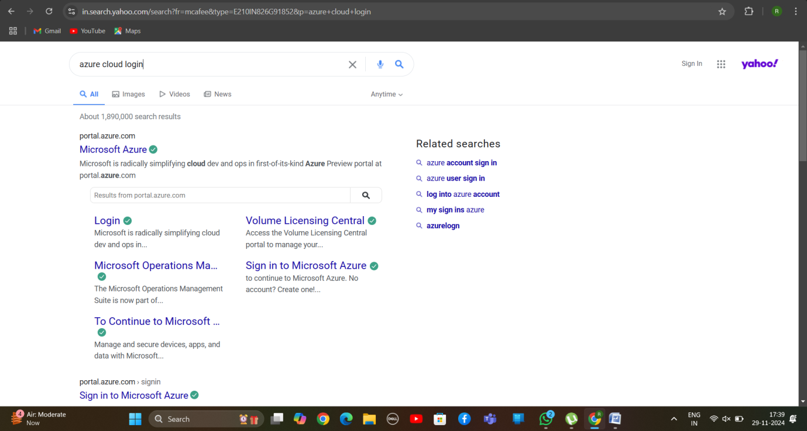

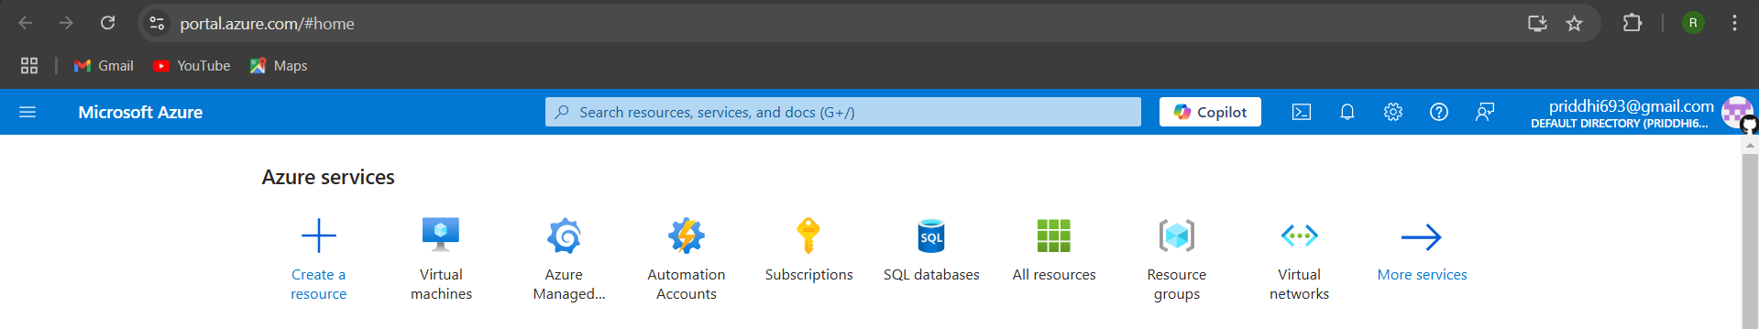

2. Create a Virtual Machine

Click on "Create a Resource".

Select Virtual Machine.

Choose the following:

Subscription: Select your subscription.

*Steps to Create a Web Server in Azure*

Resource Group: Create a new one or select an existing group.

VM Name: Provide a name for your VM.

Region: Choose a region close to you.

Image: Select either Windows Server or a Linux distribution (like Ubuntu) based on your requirements.

Size: Choose an appropriate size (standard B1s or similar for basic use).

Authentication: Use SSH or password for access.

*[Type sidebar content. A sidebar is a standalone supplement to the main document. It is often aligned on the left or right of the page, or located at the top or bottom. Use the Text Box Tools tab to change the formatting of the sidebar text box.]*

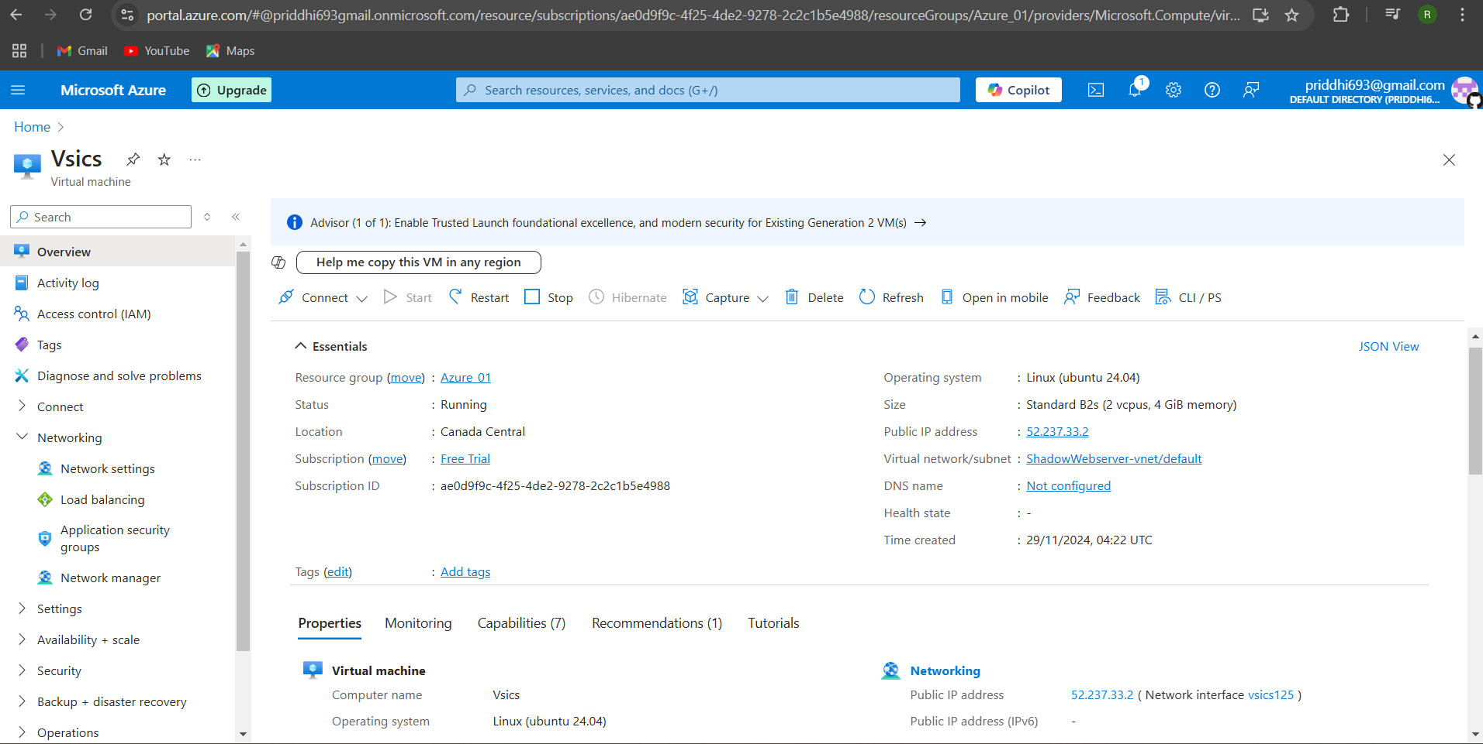

3. Configure Networking

Allow HTTP (Port 80) and SSH/RDP traffic under inbound rules for easy server and webpage access.

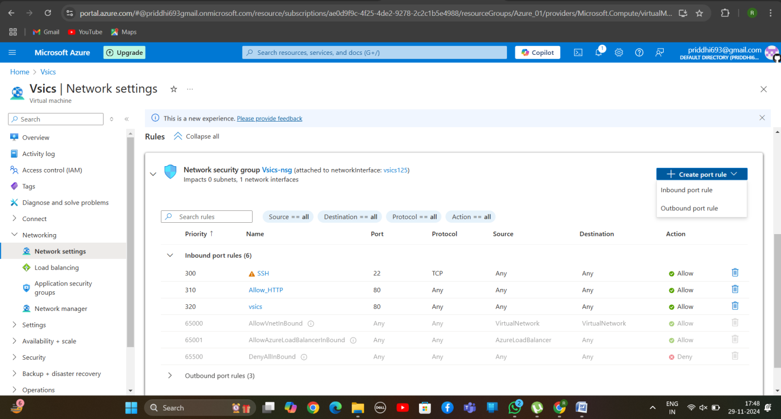

4. Deploy the VM

*[Type sidebar content. A sidebar is a standalone supplement to the main document. It is often aligned on the left or right of the page, or located at the top or bottom. Use the Text Box Tools tab to change the formatting of the sidebar text box.]*

Review your configurations and click "Create".

5. Connect to the VM

Use SSH to connect to your VM (ssh <username>@<VM-IP>).

Then password.

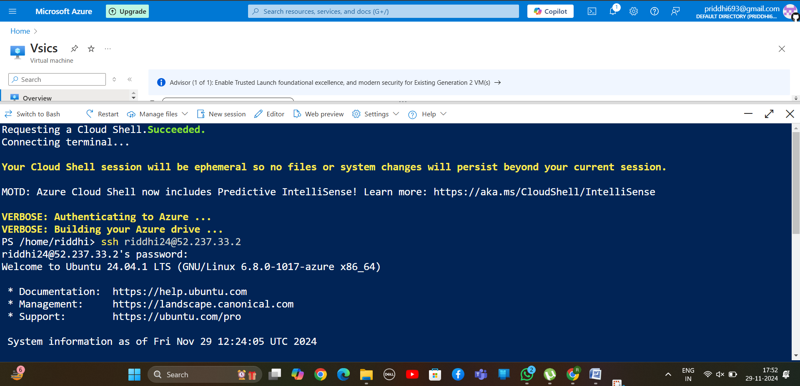

6. Install Web Server

(Ubuntu example):

Update the package list: sudo apt update.

Install Apache: sudo apt install apache2.

*[Type sidebar content. A sidebar is a standalone supplement to the main document. It is often aligned on the left or right of the page, or located at the top or bottom. Use the Text Box Tools tab to change the formatting of the sidebar text box.]*

Start the service: sudo systemctl start apache2.

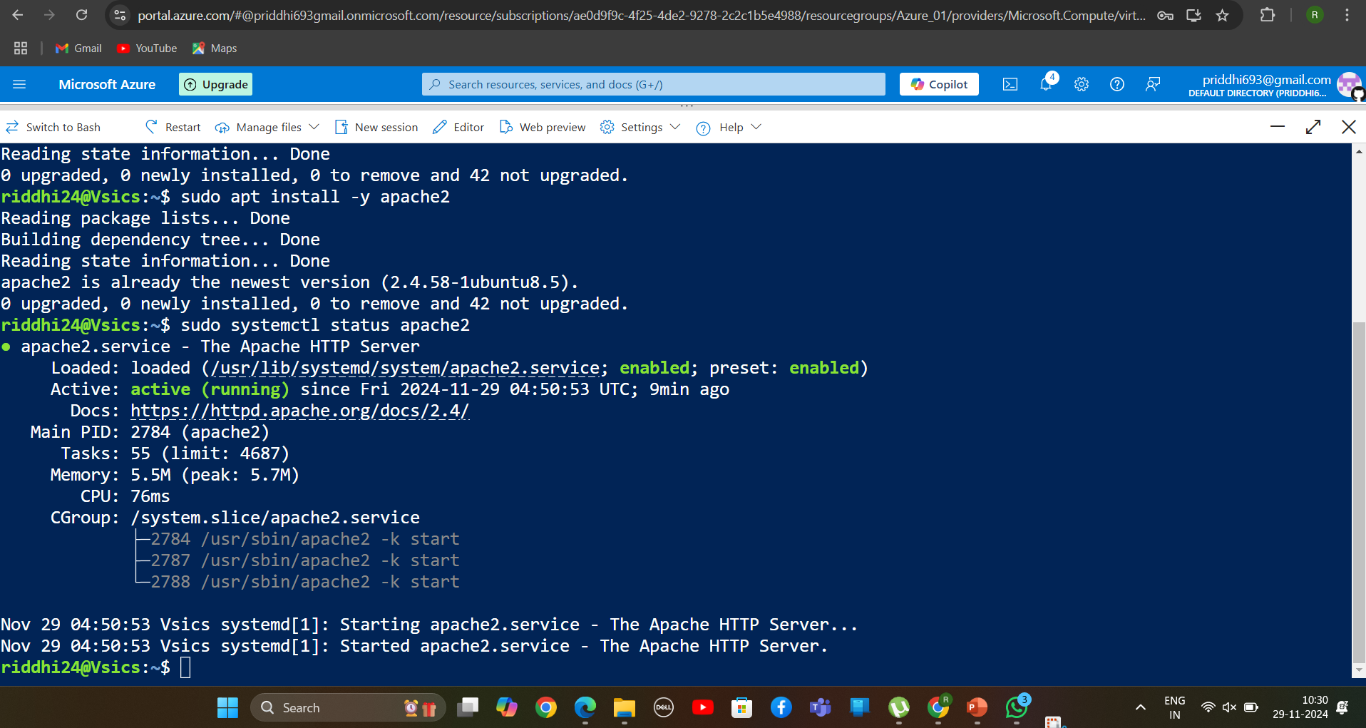

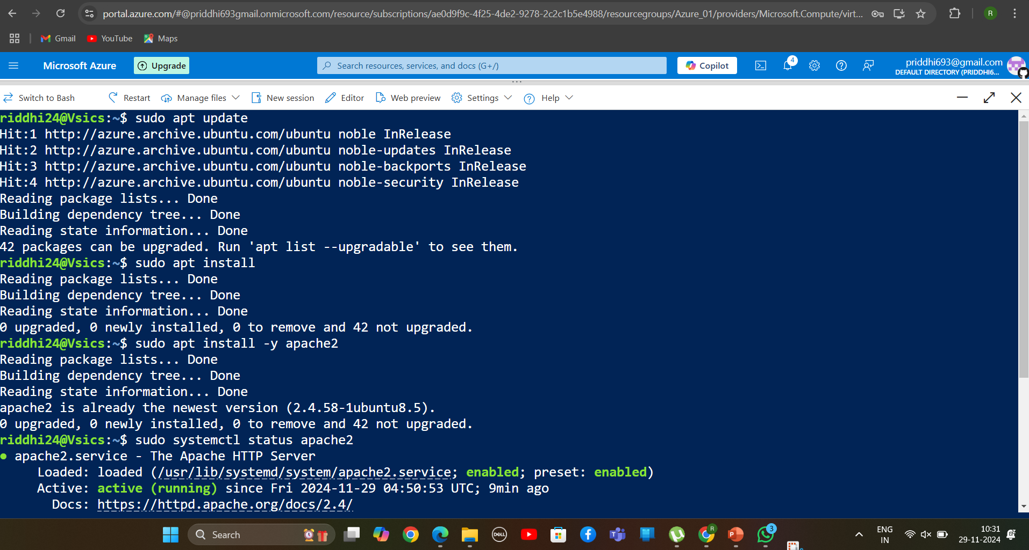

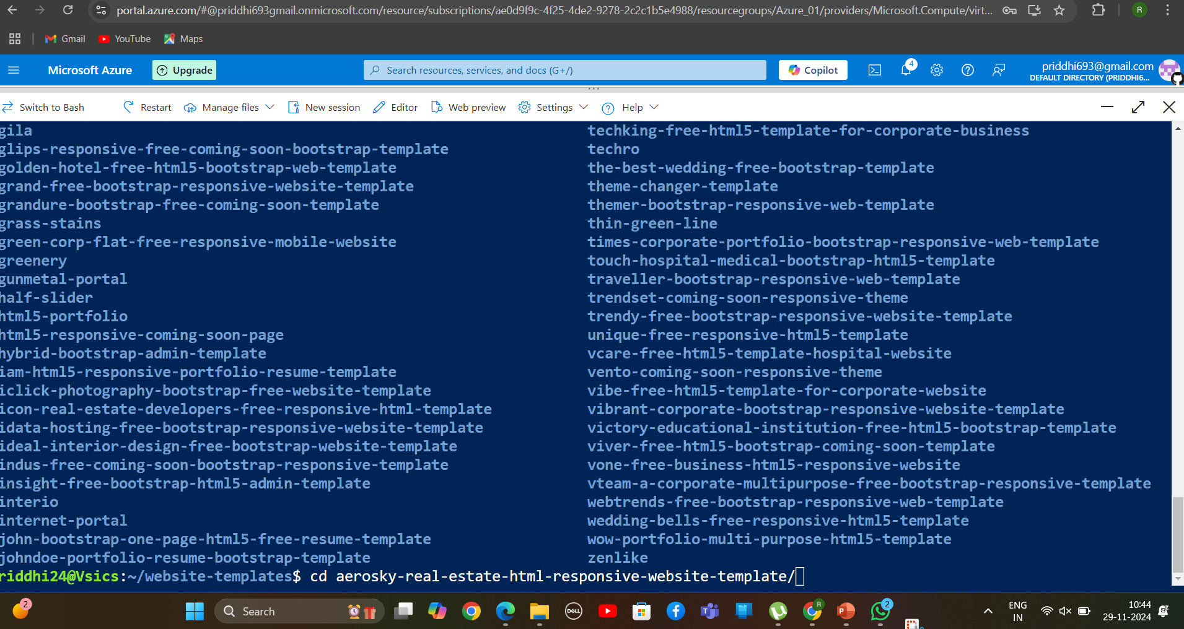

*[Type sidebar content. A sidebar is a standalone supplement to the main document. It is often aligned on the left or right of the page, or located at the top or bottom. Use the Text Box Tools tab to change the formatting of the sidebar text box.]*

7. Host a Webpage

Replace the default webpage with your custom file:

For Linux: Place your HTML file in /var/www/html/.

8. Access the Webpage

Open your VM's public IP in a browser to see your hosted webpage.

*[Type sidebar content. A sidebar is a standalone supplement to the main document. It is often aligned on the left or right of the page, or located at the top or bottom. Use the Text Box Tools tab to change the formatting of the sidebar text box.]*

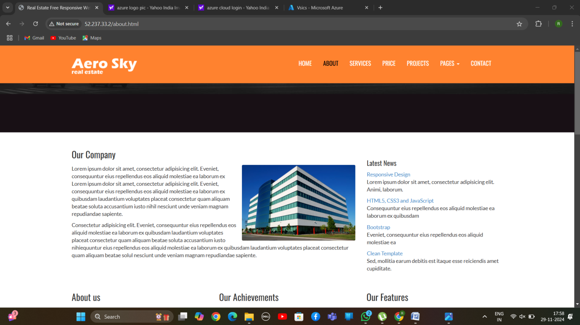

Thank You….!!

By TEAM-H